5.61: For an angle of 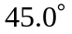, the tensions in the horizontal and vertical wires will be the same. a) The tension in the vertical wire will be equal to the weight 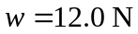; this must be the tension in the horizontal wire, and hence the friction force on block A is also 12.0 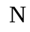. b) The maximum frictional force is 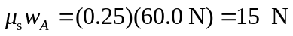; this will be the tension in both the horizontal and vertical parts of the wire, so the maximum weight is 15 N.

